Travis Lageman
GES 686
Final Project
5/23/18

Project Description:
The purpose of this study is to explore how and where resources, provided by Baltimore City Department of Public Works (DPW) GROW (Green Resources and Outreach for Watersheds) Centers, are accessed by city residents. This study looks specifically at where GROW Center users originate, and the demographics of these areas. In doing so, insight into the relationships between Baltimore City residents and GROW Center pop-ups is revealed. The target population in this study are GROW Center users/attendees.
Background:
Baltimore City Department of Public Works (DPW) received funding from United States Department of Agriculture/United States Forestry Service to develop the GROW Center concept. GROW Centers are envisioned as “greening resource hubs” or places where residents and communities access low or no cost greening resources to help meet city goals. These goals include increasing the urban tree canopy, promoting stormwater management on private property, encouraging vacant lot revitalization, and also encouraging the reuse of materials otherwise deemed as waste. Resources include the physical: mulch, trees, native plants, and deconstruction materials; and the educational: training and informational. DPW is currently and continuing to develop pilot pop-up GROW Centers. These pilots will guide efforts to create a permanent, replicable GROW Center model. One of their main questions in performing these pop-ups is to understand which residents are accessing these centers and resources.
Data:
Data were collected from open data sources and at GROW Center pop-up events. These events took place over the course of four weekends from April to May 2018 in four locations across Baltimore City. At these pop-ups residents attended to obtain resources or attend various educational workshops. Participant addresses were collected from GROW Center attendees upon checking-in to the events. After geocoding, this data was cleaned to remove unnecessary fields and examined for errors. Baltimore Neighborhood Indicators Alliance (BNIA) –Jacob France Institute was sourced for the Baltimore City community statistical area maps as well as associated indicator data. Indicator data was from BNIA’s Vital Signs datasets. The most recent available datasets were used for each indicator in analysis. These indicators included: Measurements for Percentage of Residential Properties that are Vacant & Abandoned (2016), Number of Community Managed Open Spaces (2015), Median Household Income (2015) and Percentage of Area Covered by Trees (2011).
Methods:
Participant addresses were collected from GROW Center Pop-up events and geocoded using ArcGIS World Gecoding Locator to obtain Latitude and Longitude coordinates for each participant. All other data and results were organized, analyzed, and produced in ArcMap and Microsoft Excel. Before analysis, each shapefile was projected to the same projected coordinate system: NAD 1983 State Plane Maryland FIPS 1900 Feet. Three primary analyses were performed in this study: (1) Characteristics of distance traveled to GROW Centers (2) A Kernel Density analysis of GROW Center participants (3) A comparison of High, Medium and Low Density participant areas.
(1) To determine characteristics of distance traveled to GROW Centers by participants, geocoded data was assigned a unique identifier based on which pop-up GROW Center it belonged to. For example, the location point of pop-up #1 and all associated participant locations that attended pop-up #1 were assigned a value of 1 in the created field, PopUpNum. The “Point Distance” tool was used on each set of pop-up data to determine the distance of each participant to the respective pop-up location. The same analysis was performed on a set of 100 randomly generated points for comparison. This data was exported to Excel, where the average, minimum, maximum, and standard deviation values were calculated using excel functions.
(2) A kernel density map of GROW Center participants from all four pop-ups was produced using ArcMap’s “Kernel Density” tool with default settings. Natural Jenks Classification was selected for displaying five breaks in the data to identify any underlying trends. The raster was reclassified into three categories: High, Medium and Low Density. The first break was Low, middle two breaks were Medium and last two breaks were High. This raster was overlaid with Baltimore City to show community statistical areas of high, medium and low GROW Center Participant density.
(3) Comparison of High, Medium and Low-density areas was performed using ArcMap’s “Zonal Statistics” tool on the reclassified kernel density raster. In order to perform the zonal statistics, rasters were created from each indicator of interest provided by BNIA Community Statistical Area data. After creating rasters, average values of each indicator raster (Vacant properties, Tree Canopy, Median Income, and Community Spaces) could be calculated and recorded. All maps were produced and exported in ArcMap layout.
Results:
If we examine Figure 1, it would appear that GROW Center participants tended to originate from points nearer each Center but some still traveled a distance to reach the Centers (see max distances). Analysis showed that many GROW Center participants attended from somewhat closer, more local areas in relation to each Center. This can be inferred from the average distance traveled being less (~2 miles less) than that calculated for random points. Additionally, standard deviations for each measured pop-up sample were relatively small, indicating less variability in distance traveled. The exception was Pop-up #4 where some outliers most likely skewed the calculation of standard deviation (See Figure 1). Results from the distance analyses can be found in Table 1.
Table 1: (All numbers in miles)
Pop-up Number | 1 | 2 | 3 | 4
Average Distance (Actual) | 2.04 | 2.87 | 2.12 | 2.76
Max Distance | 5.68 | 6.05 | 5.96 | 9.26
Min Distance | 0.06 | 0.00 | 0.06 | 0.05
Standard Deviation | 1.51 | 1.78 | 1.55 | 2.70
Average Distance (Random) | 3.71 | 4.05 | 3.70 | 5.13
Max Distance | 7.91 | 7.78 | 7.63 | 11.00
Min Distance | 0.24 | 0.14 | 0.22 | 1.10
Standard Deviation | 1.95 | 1.79 | 1.72 | 2.09
Upon classifying GROW Center Participants into High, Medium and Low-Density areas, characteristics of GROW Center participants were illuminated. Classification areas can be seen in Figure 2. Zonal statistics on each area revealed that High and Medium Density areas of GROW Center users had lower median household incomes, higher percentages of vacant properties, higher numbers of community managed open spaces and less tree canopy cover as compared to Lower Density areas.
Table 2:
Year | Indicator | High | Med | Low
2016 | Median Household Income ($) | 38,325 | 47,926 | 50,267
2015 | % Residential Properties that are vacant and abandoned | 12.83 | 6.56 | 3.03
2015 | Number of Community Managed Open Spaces | 27.81 | 13 | 3.75
2011 | % Tree Canopy Cover | 21.31 | 27.96 | 28.65

Conclusions:
Results indicate that GROW Centers attracted a notable local population of participants that also included more distant travelers (Figure 1). This suggests that GROW Centers in different locales are effective at reaching more local greeners. Additionally, most residents using GROW Center resources come from areas of lower income, less trees, more vacant properties and more community open spaces. This is reassuring for GROW Center objectives. Resources provided through GROW Centers are targeted towards community greening activities that promote vacant lot revitalization, maintenance of greenspaces and to increase tree canopy.
Furthermore, by providing materials for free and low cost, residents with little disposable income are able to access materials. Looking at Figure 2, areas of high participant density occur in East and West Baltimore, historically underserved neighborhoods with high numbers of vacancies and lower income. Therefore, it appears that GROW Centers can provide resources for community greening related efforts in areas that can benefit most.
Figure 1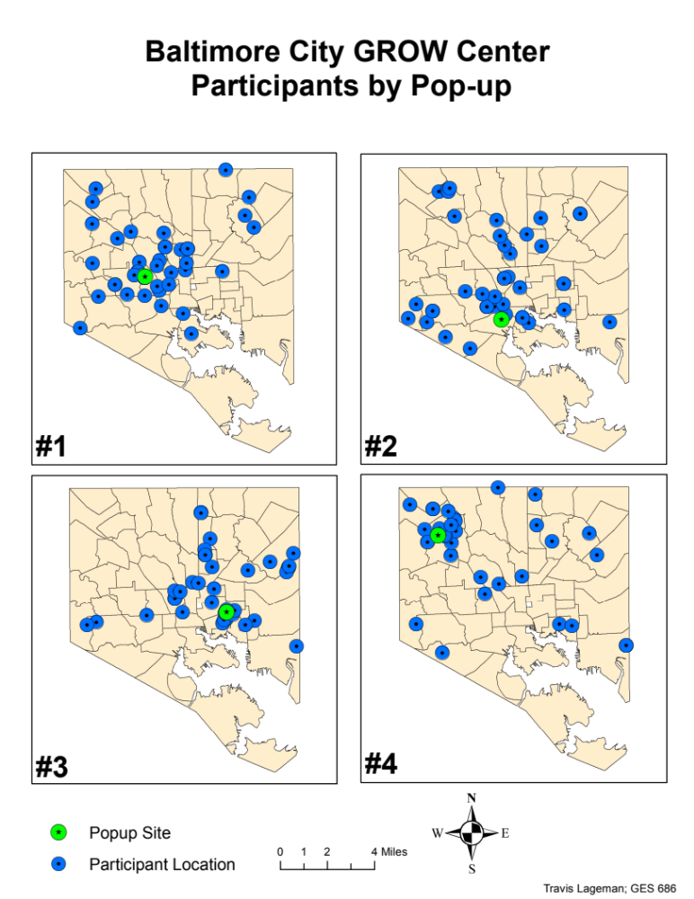Figure 2

